**Keywords and Custom Exceptions**

1. Writing a program in Java to demonstrate the **throw** keyword

**package** Pack3;

**public** **class** ThrowDemo {

**public** **static** **void** main(String[] args)

{

**int** a=45,b=0,rs;

**try**

{

**if**(b==0)

**throw**(**new** ArithmeticException("Can't divide by zero."));

**else**

{

rs = a / b;

System.***out***.print("\n\tThe result is : " + rs);

}

}

**catch**(ArithmeticException Ex)

{

System.***out***.print("\n\tError : " + Ex.getMessage());

}

System.***out***.print("\n\tEnd of program.");

}

}

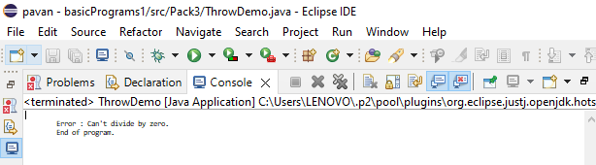

// output: Error: Can’t divide by zero

End of program

1. Writing a program in Java to demonstrate the **throws** keyword

**package** Pack3;

**public** **class** ThrowsDemo {

**void** Division() **throws** ArithmeticException

{

**int** a=45,b=0,rs;

rs = a / b;

System.***out***.print("\n\tThe result is : " + rs);

}

**public** **static** **void** main(String[] args)

{

ThrowsDemo T = **new** ThrowsDemo();

**try**

{

T.Division();

}

**catch**(ArithmeticException Ex)

{

System.***out***.print("\n\tError : " + Ex.getMessage());

}

System.***out***.print("\n\tEnd of program.");

}

}

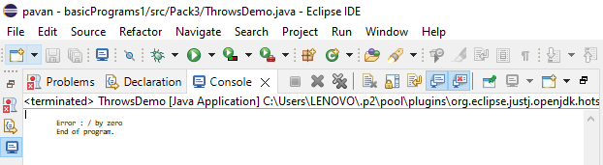

// output: Error: / by zero

End of program

1. Writing a program in Java to demonstrate the **finally** keyword

**package** Pack3;

**public** **class** FinallyBlockDemo {

**public** **static** **void** main(String[] args)

{

**int** a=45,b=0,rs=0;

**try**

{

rs = a / b;

}

**catch**(ArithmeticException Ex)

{

System.***out***.print("\n\tError : " + Ex.getMessage());

}

**finally**

{

System.***out***.print("\n\tThe result is : " + rs);

}

}

}

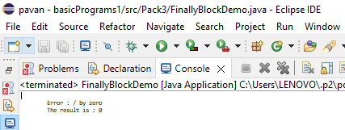

// Error: / by zero

The result is : 0

1. Writing a program in Java to demonstrate the **Custom Exeception**

**package** Pack3;

**class** MyException **extends** Exception

{

**public** MyException(String s)

{

**super**(s);

}

}

**public** **class** Main

{

**public** **static** **void** main(String args[])

{

**try**

{

**throw** **new** MyException("temp");

}

**catch** (MyException ex)

{

System.***out***.println("Caught");

System.***out***.println(ex.getMessage());

}

}

}

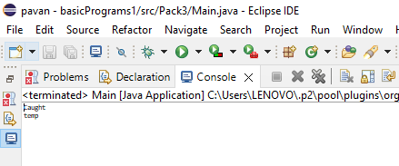

// Output : Caught

Temp